Visualization 1 — Elbow Method
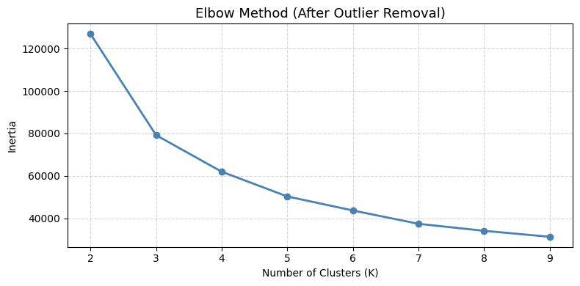
The elbow curve plots inertia (within-cluster variance) against the number of clusters from K=2 to K=9. The curve shows a steep decline from K=2 to K=4, after which the rate of improvement slows significantly. While the curve does not show a sharp single elbow — common in real-world e-commerce data with overlapping customer behaviors — K=4 represents the optimal balance between model complexity and cluster distinctiveness. Beyond K=4, additional clusters offer diminishing returns in explaining customer variance, making 4 segments the most practical and interpretable choice for business decision-making.

Visualization 2 — Customer Count by Segment
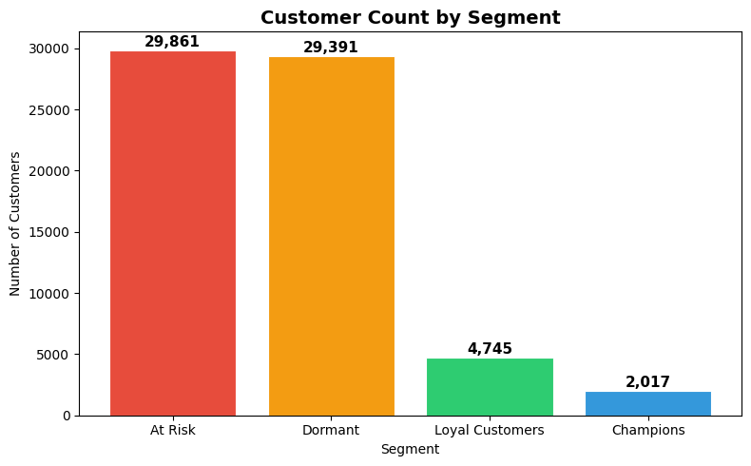
The bar chart reveals a heavily skewed distribution across the four segments. At Risk (29,861) and Dormant (29,391) customers together account for nearly 89% of the entire customer base, while Champions (2,017) and Loyal Customers (4,745) represent only 11%. This pattern is consistent with the Pareto principle in e-commerce — a small minority of highly engaged customers coexist with a large base of inactive or disengaged ones. The sheer volume of At Risk customers presents the single largest re-engagement opportunity, while the small Champion segment likely drives a disproportionate share of total platform revenue.

Visualization 3 — Average Spending by Segment
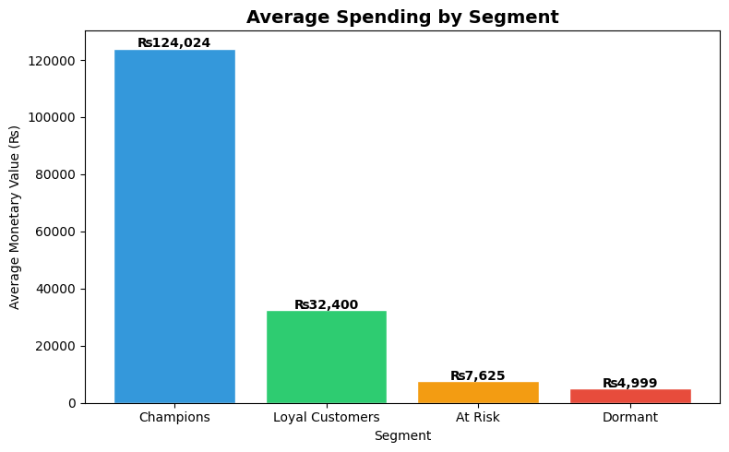
The spending gap between segments is dramatic. Champions average ₨124,024 per customer — approximately 16x more than Dormant customers (₨4,999) and 4x more than Loyal Customers (₨32,400). At Risk customers average only ₨7,625 despite being the largest segment by volume. This indicates that customer value is highly concentrated at the top — retaining even a fraction of Champions or converting Loyal Customers upward would yield significantly higher revenue than activating large numbers of At Risk or Dormant customers. Marketing budget allocation should reflect this spending hierarchy.

Visualization 4 — Recency vs Monetary Value by Segment
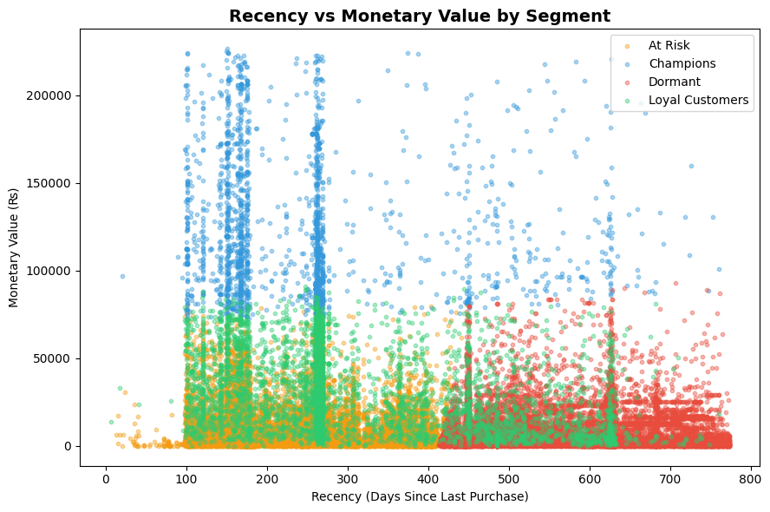
The scatter plot reveals two key patterns. First, Champions (blue) appear across the full recency spectrum — from 0 to 800 days — and consistently at higher monetary values, confirming they are high spenders regardless of how recently they purchased. This suggests Champions are driven by product affinity rather than recency-based triggers. Second, Dormant customers (red) cluster heavily in the 500–800 day recency range at low monetary values, confirming long disengagement combined with low historical spend. At Risk (orange) and Loyal (green) customers overlap significantly in the 100–400 day range, suggesting these two segments are the most fluid and most responsive to targeted intervention campaigns. The vertical clustering patterns around days 100, 150, 270, and 450 likely reflect platform-level promotional events that triggered purchase spikes across all segments simultaneously.

